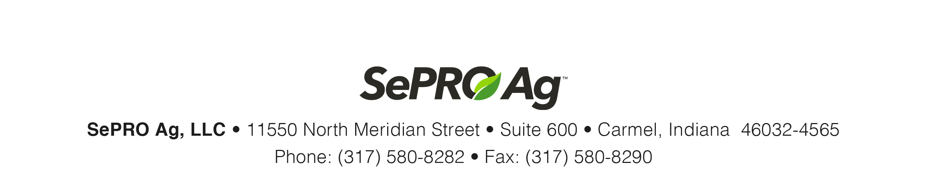

Job Title: | Technical Specialist, SePRO Ag
Location: | Mid-South, West Region (Arkansas preferred)
Supervisor Title: | Director, SePRO Ag

JOB SUMMARY
SePRO Corporation is a specialty environmental products company committed to protecting, preserving, and restoring nature. Through a tireless commitment to customer-centric innovation and solution-focused technical support, SePRO is poised for continued growth and market leadership.

We are seeking an outstanding team player with high learning agility who thrives on delivering value to customers through technical support and outstanding customer service. The ideal candidate will have a track record of meeting or exceeding sales goals and a commitment to continuous learning and personal development.

PRIMARY RESPONSIBILITIES
Sales Territory: Arkansas, Missouri, Texas, Kansas
(Note: Concentration of related travel to be in Arkansas and Missouri)
- Create sales demand at grower/producer and consultant level through education and demonstration of SePRO AG technical expertise and product(s) value.
- Call on distributor sales agronomists and retail location managers to plan and conduct high-impact activities that drive sales
- Provide technical training to key audiences, which include growers, distributor and retail personnel, consultants, and other related stakeholders.
- Implement sales and marketing programs in collaboration with distribution and retail customers to ensure territory revenue objectives are met.
- Build and maintain relationships with customers and potential customers to promote, sell, and steward SePRO Ag solutions that are aligned with market strategies, and develop tactics to support growth in product use.
- Introduce and represent the appropriate use of products at industry meetings, customer training events and other end-user outreach opportunities.
- Communicate market intelligence effectively within the organization including competitive analysis and acre share by product and crop.
- Utilize CRM software to manage customers, contacts, sales calls, leads and development initiatives.
- Actively contribute to a team environment as both a leader and participant.

EDUCATION, QUALIFICATIONS AND EXPERIENCE
- Bachelor’s degree
- 5+ years of experience with crop protection or seed products in agricultural markets.
- Sales experience that includes educating and influencing end-users
- Existing relationships with growers, consultants, retail sales agronomists, and university researchers
- Demonstrated results in taking new products to market through building value-creation based relationships
- Excellent presentation and communication skills
- Strong organizational and time management skills
- Business acumen and customer focus
- Computer proficiency with Microsoft Office Suite

OTHER REQUIREMENTS
- The candidate must have the ability to travel on a regular basis, locally and overnight, for product stewardship, technical support, and other sales related efforts.

About SePRO Ag LLC
SePRO Ag was created in 2021 as a business unit of SePRO Corporation to bring unique crop protection products to specialty crop markets. SePRO Ag is now a limited liability corporation. More information is available at ag.sepro.com.

SePRO Corporation provides equal employment opportunities to all employees and applicants for employment and prohibits discrimination and harassment of any type without regard to race, color, religion, age, sex, national origin, disability status, genetics, protected veteran status, sexual orientation, gender identity or expression, or any other characteristic protected by federal, state, or local laws. This policy applies to all terms and conditions of employment, including recruiting, hiring, placement, promotion, termination, layoff, recall, transfer, leaves of absence, compensation, and training.

